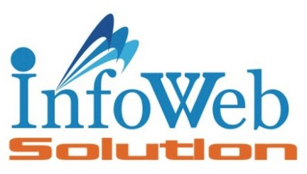

Sunny Chevli

M.Sc. (I.T.)

25, Vatsalaya Bunglow, Vesu, Surat-395007 . Ph: +91 99092 84838

Date: 9th Dec, 2024

*Certificate*

This is to certify that **Dhruvin Jariwala** has successfully carried out a website development project at our institute as part of his academic activity for the J.P. Dawer Institute of Information Science and Technology - B.Sc. (IT) & M.Sc. (ICT).

During this project, he developed a **Subscription Management System** using **.NET Core**, **React Vite**, and **PostgreSQL**.

As part of our policy, we do not allow the source code or design documents to leave our premises. However, as this is an academic project, he is permitted to take some design documents for academic purposes to be presented to the authorities of your institute only.

For InfoWeb Solution

Sunny Chevli